Neural Style Transfer
Neural Style Transfer is a fascinating process where a pre-trained convolutional neural network (CNN) calculates the cost of an image generated by our own network, which modifies the pixels of the generated image.
The procedure can be described as generating an image 'g' by augmenting the content of an image 'c' with the style of another image 's'. This is achieved using the layers of a pre-existing CNN image classifier to calculate a content cost and a style cost. The content cost corresponds to the difference between the activations with the generated image 'G' and the content image 'C' in an early layer. The style cost, on the other hand, is evaluated by comparing the correlations of channels with the generated image 'G' and style image 'S' in later layers.
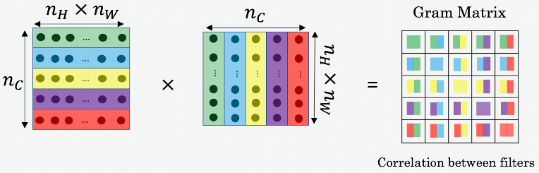

Let's break down the process into steps:
- Updating Anaconda and Installing Tensorflow: The first step involves ensuring you're working with the latest version of Anaconda and installing Tensorflow, a powerful open-source library for machine learning.
- Selecting the Model: For this process, we're using the VGG-19 model with an image size of (300, 400). Other great candidates include the FixEfficientNet-B0-B4 models, all of which perform well and have few parameters. You can load the VGG-19 model with the following code:
Note that we are constrained by the fixed image size of most CNNs, which may require the downscaling of inputs and upscaling of outputs.
The idea is to leverage images with optimal lighting conditions and the like as style references, while using your preferred image as content. This can potentially yield an enhanced image of your choice with desirable lighting conditions.
For further exploration, feel free to refer to these resources:
- Neural Style Transfer GitHub repository
- Beautiful Results with Neural Style Transfer
- Neural Algorithm of Artistic Style paper
- How Neural Style Transfers Work.
Credit: Sayak Dasgupta's Neural Style Transfer Using VGG19 on Kaggle

